RESOLUTION NO.__________

RE: CERTIFICATE OF APPROPRIATENESS UNDER THE
PROVISIONS OF THE ACT OF THE PENNSYLVANIA
LEGISLATURE 1961, JUNE 13, P.L. 282 (53
SECTION 8004) AND BETHLEHEM ORDINANCE NO.
3952 AS AMENDED.

WHEREAS, it is proposed to improve the facades of three dwellings at 414-416-418 Hayes Street.

NOW, THEREFORE, BE IT RESOLVED by the Council of the City of Bethlehem that a Certificate of Appropriateness is hereby granted for the work.

Sponsored by: (s)

(s)

ADOPTED BY COUNCIL THIS DAY OF

(s)
President of Council

ATTEST:

(s)
City Clerk

HISTORIC CONSERVATION COMMISSION

CASE # 596– It is proposed to improve the facades of three dwellings at 414-416-418 Hayes Street
OWNER/APPLICANT:(414) Elizabeth Cerva:(416) Peter Anewalt:(418) Lehigh Valley Community Land Trust/ Community Action Committee of the Lehigh Valley

The Commission upon motion by Mr. Lader seconded by Mr. Evans adopted the proposal that City Council issue a Certificate of Appropriateness for the proposed work described herein:
- The proposal to improve the facades of three dwellings at 414-416-418 Hayes Street was represented by Lynne Holden and Mike Handzo.
- The façade renovations will be undertaken as proposed with the following modifications or clarifications:
  - The new windows will be aluminum clad wood double hung windows with 2 over 2 simulated divided lights.
  - The dormer windows may be casement style with a heavy horizontal muntin to recall the appearance of a double hung window if needed for egress requirements by the Building Codes Department.
  - The front doors will have 3/4 lights.
  - The new front porch railings will have 2” (actual) square balusters, and the porch posts will be 6” in diameter.
  - The brick facades will be cleaned using a low pressure power wash. (400 psi)
  - The roof will be shingled with GAF Slateline shingles in the Antique Slate color.
  - All wood will be repaired rather than replaced where ever possible. Epoxy consolidants and fillers should be used to repair wood as much as possible.

- The motion to approve the proposal was unanimously approved.

CU: cu
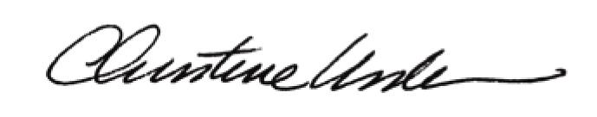

By:

Date of Meeting: September 19, 2016 Title: Historic Officer

